Halloween in Poland was called Dziady and was an ancient Slavic feast commemorating the dead.

Jacek, a strong but arrogant young man, inherited his father's flour mill. That first autumn, as Dziady approached, the older villagers began their preparations. They set out feasts for their ancestors and lit candles to guide the souls. But Jacek, full of modern hubris, saw only foolish old-world superstitions.

"What good is it to feed the dead?" he scoffed at the old caretaker, Witek. "The souls have no stomachs."

He refused to leave offerings for his own father, a kind man who had taught him the miller's trade. He even swept the mill's flour dust out the front door, a move forbidden on Dziady for fear of sweeping away good luck with it.

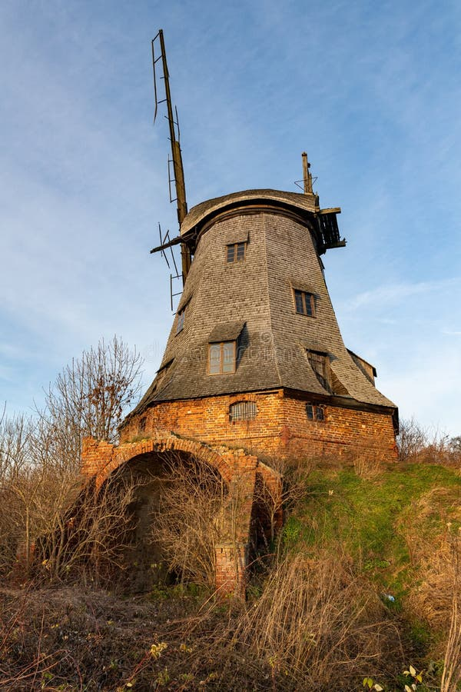

On the night of Dziady, as the boundary between worlds thinned, Jacek heard a ravenous pounding on his mill door. A chorus of ghastly, bird-like shrieks followed. He opened the door, finding only a chilling emptiness. When he returned to his meal, his bread was gone.

The next night, the pounding returned, and this time, the shrieking was closer. Jacek, rattled, saw a heavy, dark shadow pass by his window. He poured a cup of milk for his cat, but before he could, the milk turned to sour sludge.

On the third night, a blizzard raged, and the mill's gears ground to a halt. Jacek, huddled by the fire, heard the shrieks intensify into a terrifying cacophony. A gaunt, skeletal figure emerged from the shadows, its face a mask of hunger. The spirit of a cruel, heavy-hearted lord from the Mickiewicz poems, tormented by birds for its past greed, had come for Jacek. The heavy spirit pointed at the flour dust, then back at Jacek's uneaten food, and its shrieks seemed to shake the very foundations of the mill.

The heavy spirit pursued Jacek through the mill, its terrible shrieks echoing his own selfish words. Jacek scrambled to light candles, but the flames guttered out. He tried to offer food, but the spirit swatted it away. It wasn't food it wanted, but an acknowledgment of its suffering and a proper honoring of the dead.

Cornered, Jacek cried out for forgiveness. Witek, the old caretaker, arrived with a flickering torch, drawn by the commotion. He spoke to the heavy spirit, acknowledging its torment, and then turned to Jacek. "Offer a genuine prayer," he commanded, "not just food."

Jacek, humbled and terrified, began to pray aloud for the repose of all the unremembered souls. As he did, the mill's gears began to turn again. The blizzard subsided, and a new, more peaceful light glowed from Witek's torch. The heavy spirit, no longer tormented, faded back into the ethereal realm.

In the end, the village was saved, but the mill was haunted by the memory of the heavy spirit's presence. From that day on, Jacek never forgot to honor the dead during Dziady. He would leave offerings for his ancestors, treat the beggar-spirits with kindness, and never again sweep away the dust of memory from his home.